Bash Script Tasks
- Create a bash script to check if a directory is available or not.
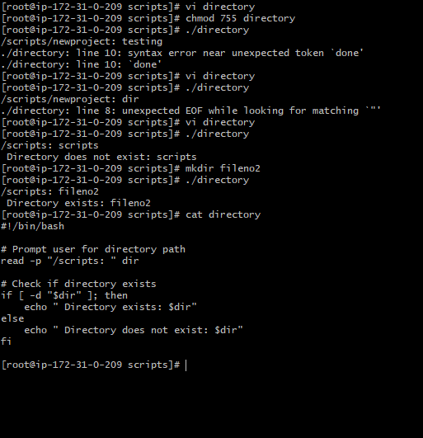
2.Create a bash script to create multiple files.
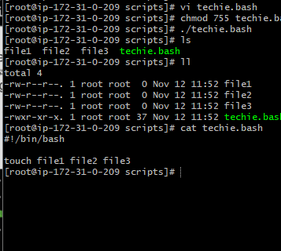

3.Create a bash script to take a backup of a directory.
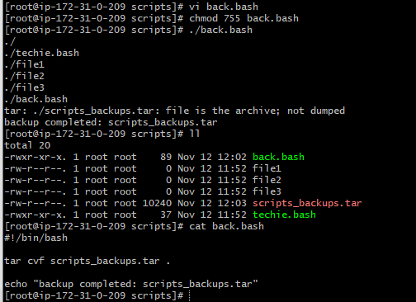

4. Create a bash script to install Nginx on an EC2 server
Yum install nginx -y
Systemctl start nginx
Systemctl enable nginx
Echo “ nginx installed successfully”
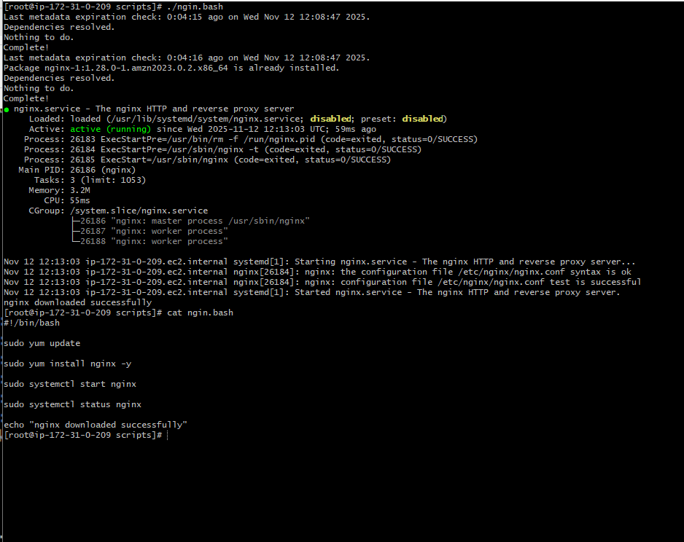
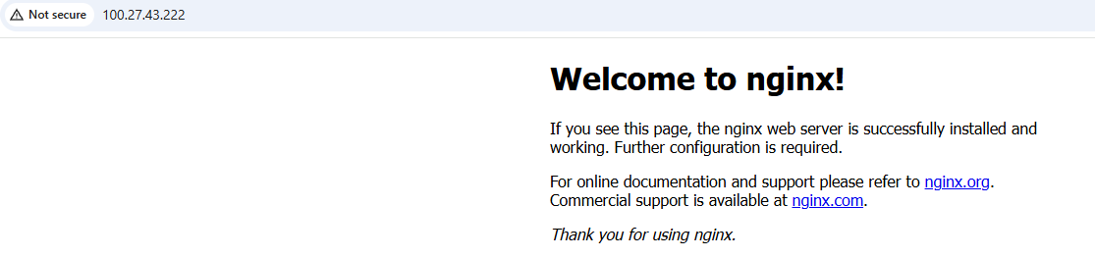

5.Create a bash script to install Apache Tomcat on an EC2 server
Ans: 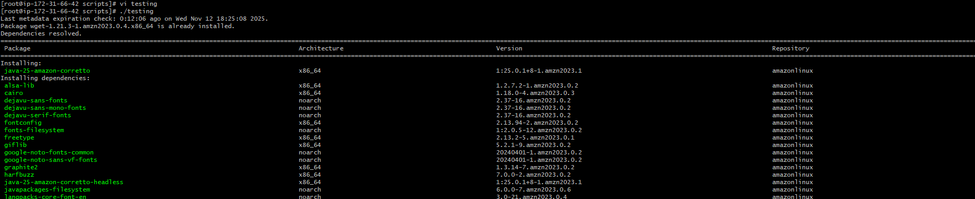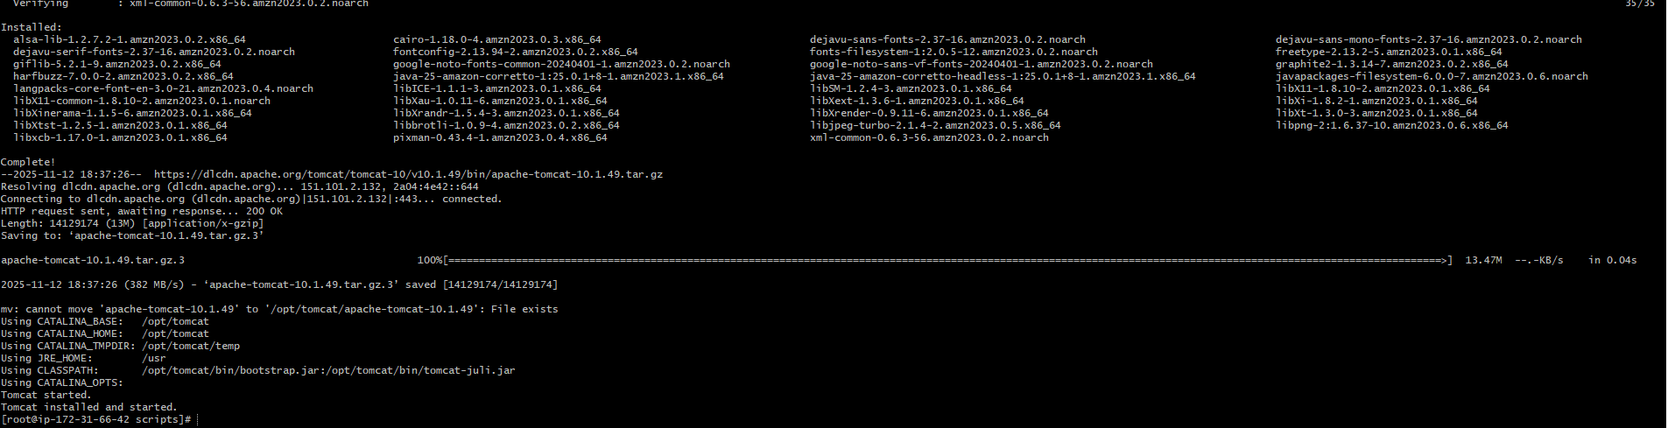
Check the site using public ip and port no 8080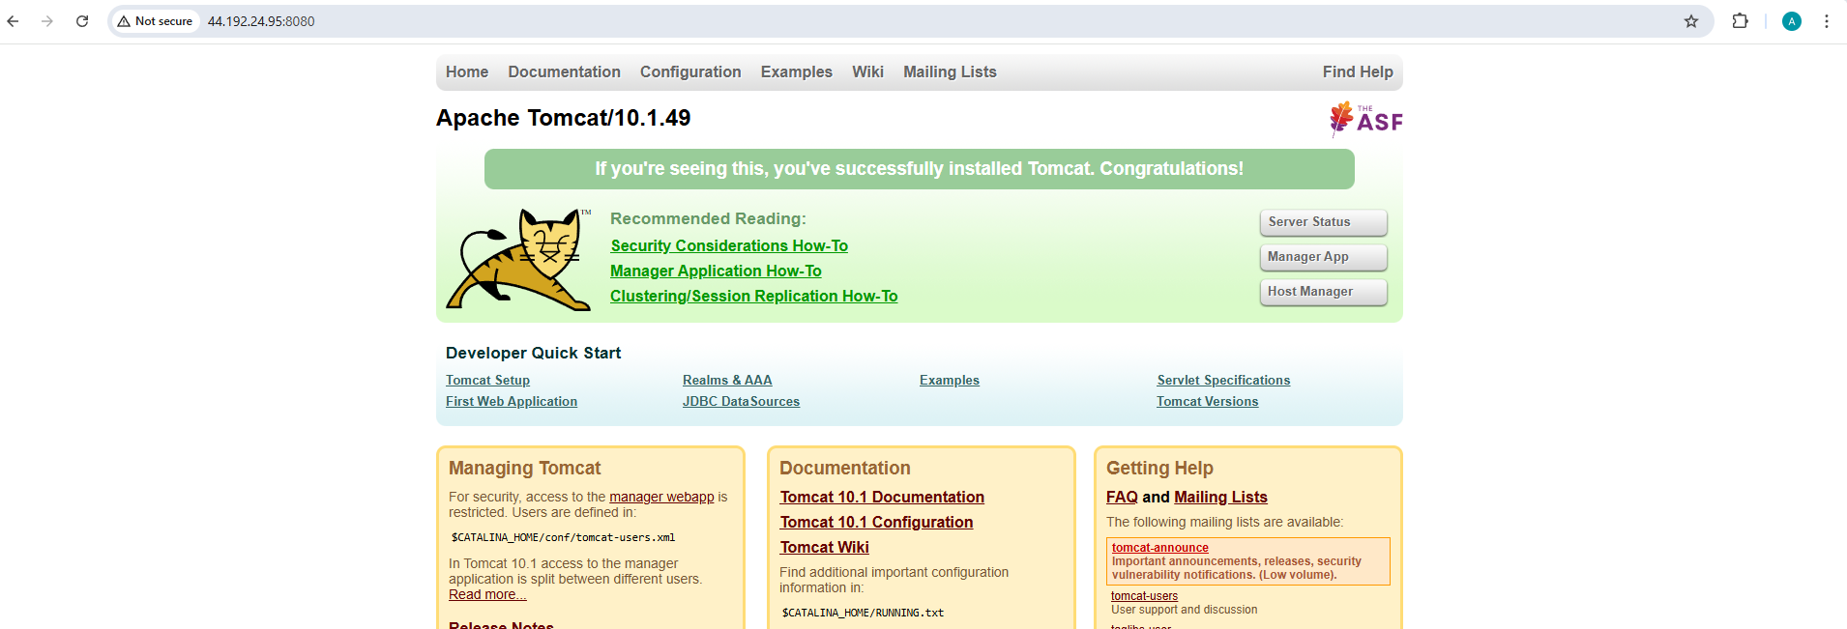
6. create a bash script to check if the Nginx service is running, if not running then script should
start the service.
Ans : 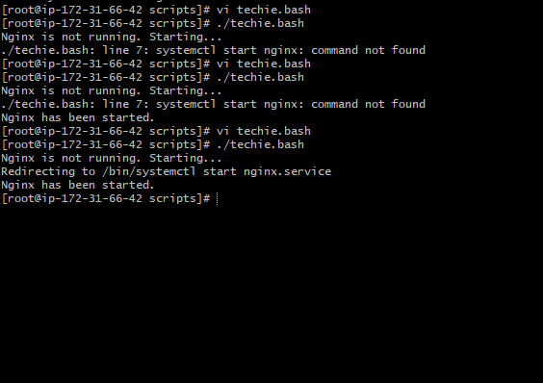
7. Create a bash script for a calculator.
Ans:
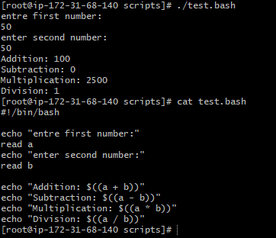

8. Create a bash script to check if a directory exists, if not then create a directory.
Ans:
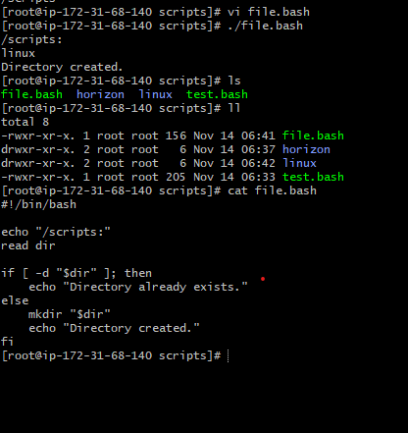

10. Create a bash script to delete the last 3 lines of a file.
Ans: To able to delete the last 3 line of a file the script will be like
#!/bin/bash

echo “entre file name:”
read file
head -n -3 “$file” > temp.txt
mv temp.txt “$file”
echo “last 3 lines deleted.”
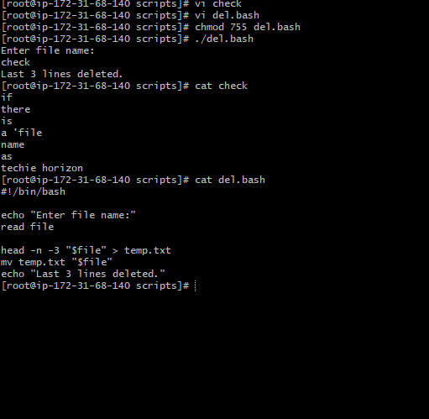
10. Bash script to monitor cpu and if it is more than 80% then send email notification.
Ans : the script will be
#!/bin/bash

cpu=$(top -bn1 | grep "Cpu(s)" | awk '{print $2 + $4}')
cpu_int=${cpu%.*}

if [ "$cpu_int" -gt 80 ]; then
echo "High CPU usage: $cpu%" | mail -s "CPU Alert" user@example.com
fi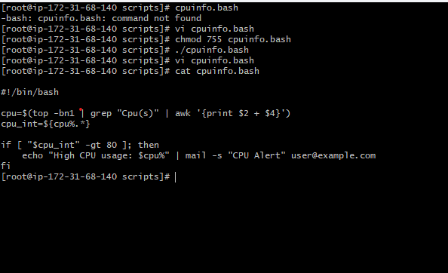

11.Bash script to monitor disk space and if it is more than 80% then send email notification.
Ans: to able to add script for disk usage checl below
#!/bin/bash

usage=$(df / | tail -1 | awk '{print $5}' | sed 's/%//')

if [ "$usage" -gt 80 ]; then
echo "Disk usage high: $usage%" | mail -s "Disk Alert" user@example.com
fi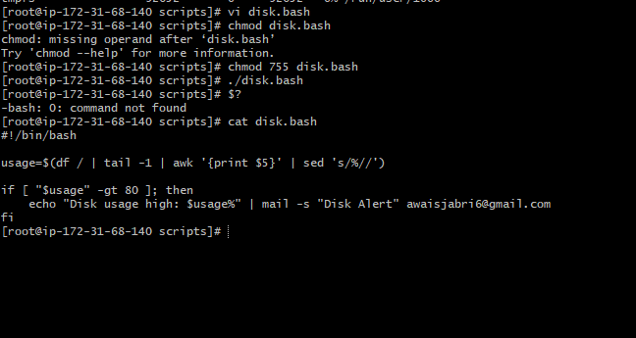

12. Bash script to monitor memory and if it is more than 80% then send email notification.
Ans : to able to monitor the memory checlk below scripts
#!/bin/bash

mem=$(free | grep Mem | awk '{print $3/$2 * 100.0}')
mem_int=${mem%.*}

if [ "$mem_int" -gt 80 ]; then
echo "High memory usage: $mem%" | mail -s "Memory Alert" user@example.com
fi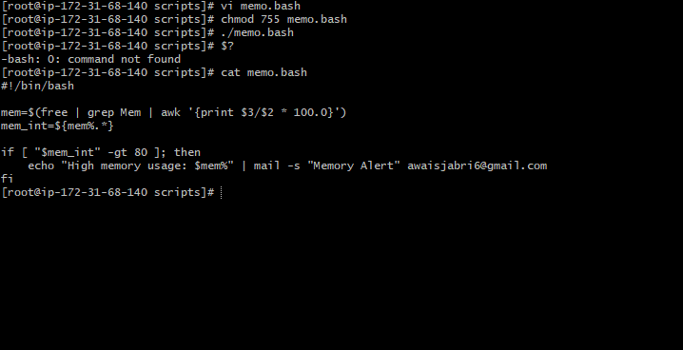

Exercise: Crontab Entries
- April 5th Midnight


- 5th of Every November, January, June if it is a Thursday
Ans:
Minute | 0 | At minute 0

Hour | 0 | At 12 AM

Day of Month |  | 5 Run on the 5th

Month |  | 1,6,11 Only January, June, November

Day of Week |  | 4 Only Thursdays

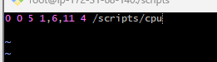

3.At 05 and 27th minutes of 9, 10, 11 hours every day
Ans: Minutes: 5,27 → at :05 and :27
Hours: 9,10,11 → during 9 AM, 10 AM, 11 AM
Day of month: * → every day
Month: * → every month
Day of week: * → every day of week
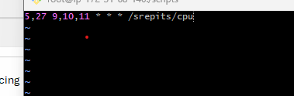
4. 34 minutes of 9th hour on 15th August
Ans: Minute: 34
Hour: 9
Day of month: 15
Month: 8 (August)
Day of week: * (any day)
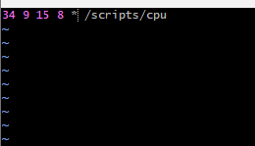
5. Every midnight
Ans: Minute: 0
Hour: 0
Day of month: * (for everyday)
Month: * (every month)
Day of week: * (any day)
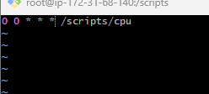
6. Every Weekend (Saturday night 11:59 PM)
Ans: Minute: 59
Hour: 23
Day of month: * (for everyday)
Month: * (every month)
Day of week: 6 (saturday)
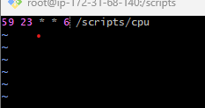

7. After every reboot
Ans: @reboot /path and need to make sure the script is executable
